

# Team 24 – Sprint 1 Testing Document

Sakshi Choudhary, Giorgi Khmaladze, Nick Litman, Mihir Somani, Conley Utz

# User Story #4

**Test 1: Given that the user is logged in and has navigated to the account settings page, the user should be able to change their username.**

Purpose: To meet the acceptance criteria the password that a user chooses must be stored as a hash.

Steps:

1. The user clicks “CHANGE USERNAME” button. 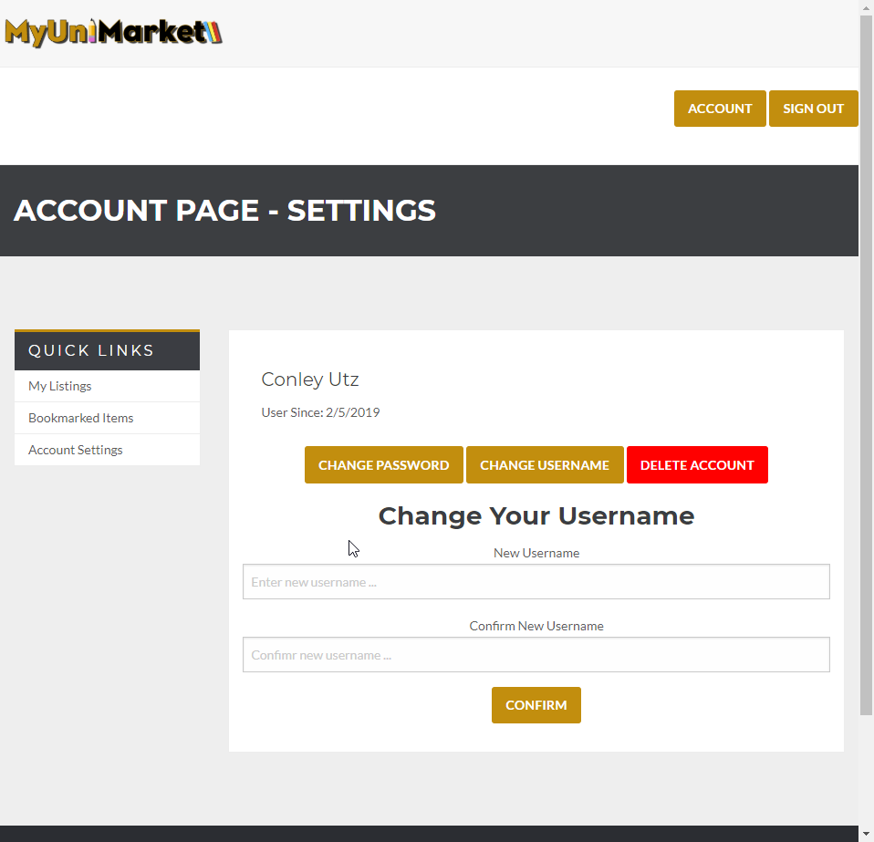
2. The user completes the required fields. 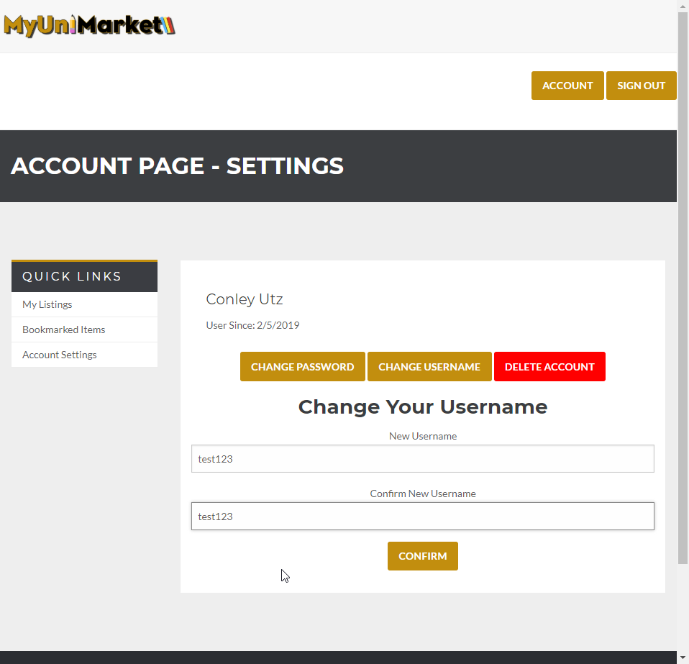
3. The database lists the username as “user1” 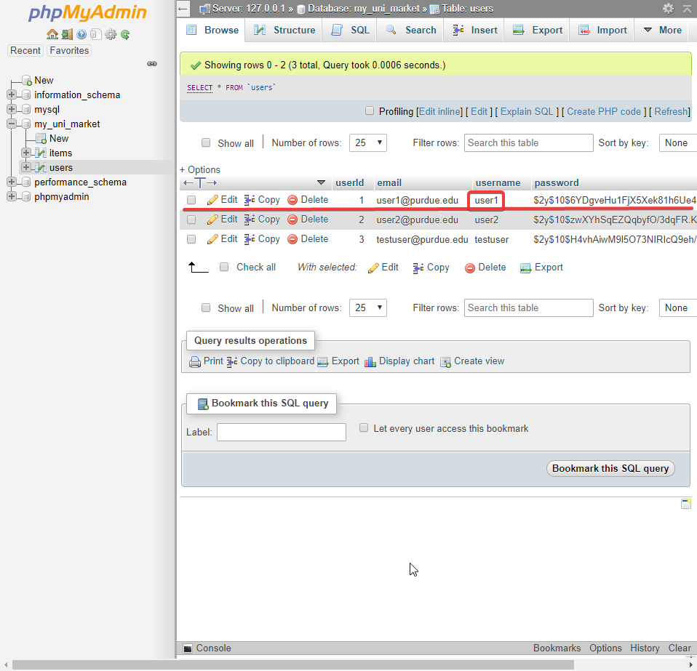
4. The user clicks “CONFIRM” and the page is reset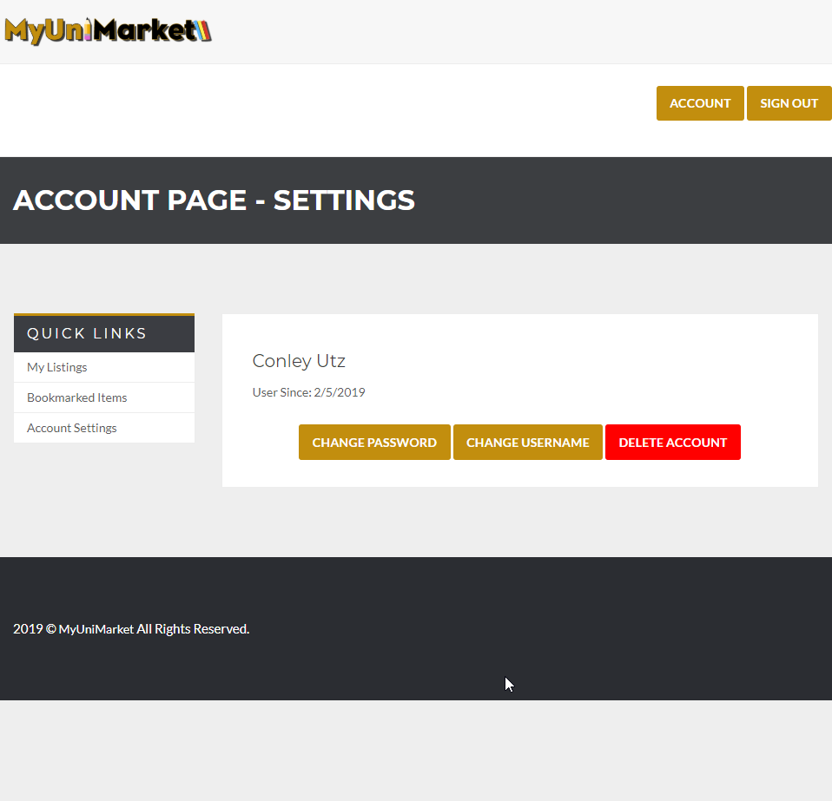
5. The username of the user is changed in the database. 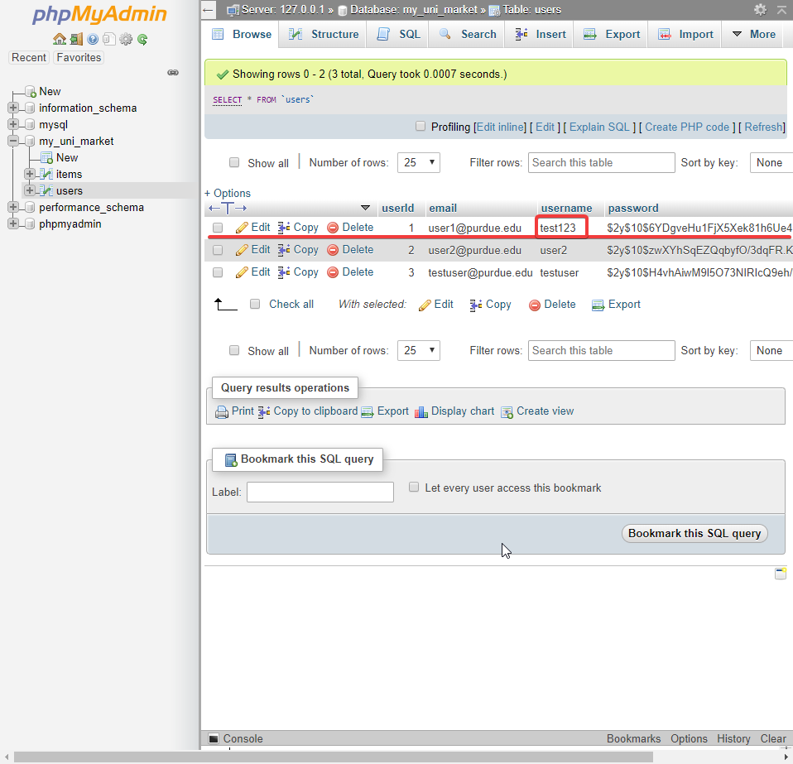

Expected Result: The username of the user should change in the database if all the fields are completed correctly.

Test Result: **PASSED**

**Test 2: Given that the user is logged in and has navigated to the account settings page, the user tries to change their password.**

Purpose: To meet the acceptance criteria the user should be able to change their password using their current details.

Steps:

1. The user clicks “CHANGE PASSWORD” button. 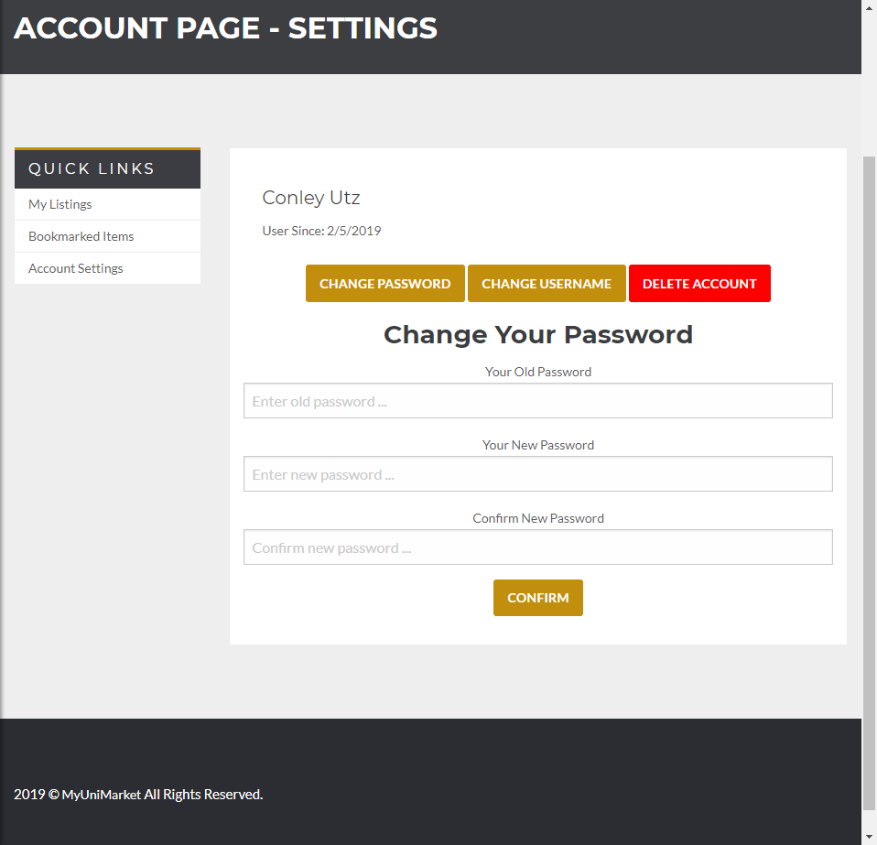
2. The user completes the fields. 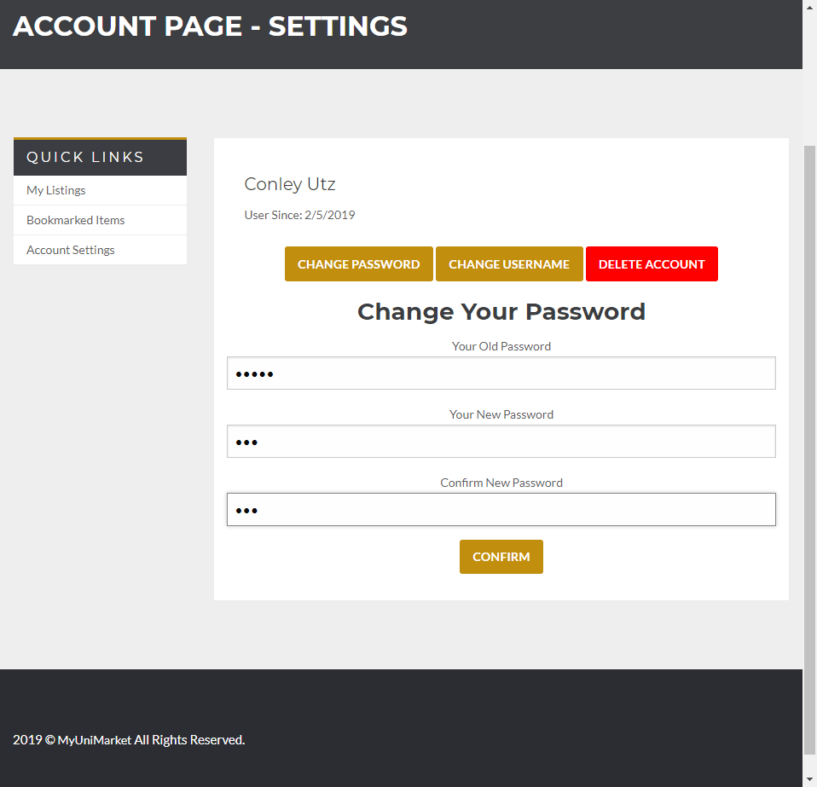
3. The database has the password stored as a hash. (the real password is ‘user1’ and the new password is ‘123’) 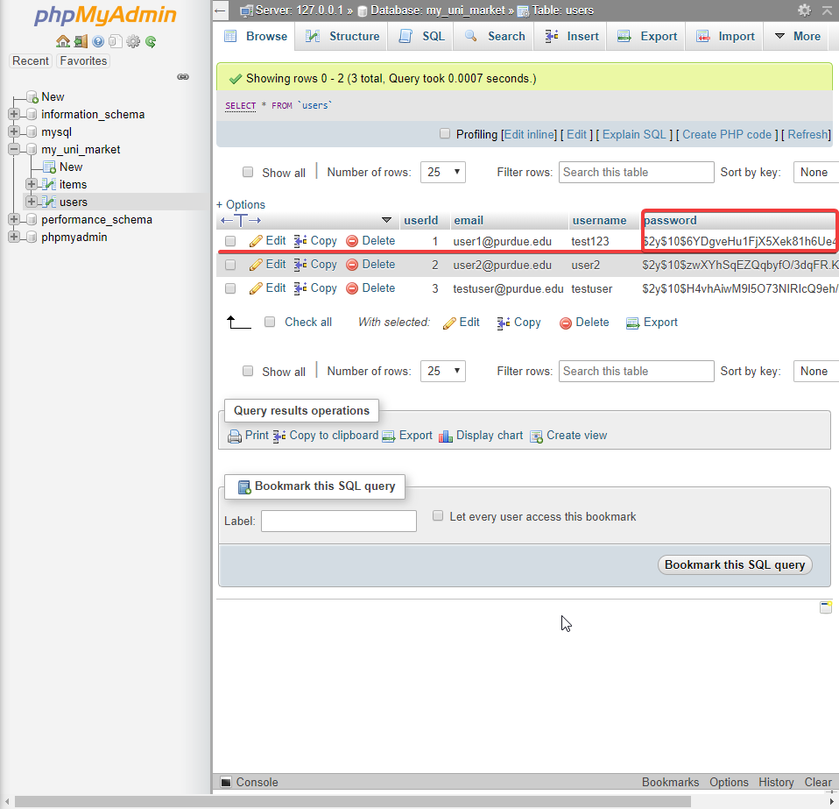
4. The user clicks “CONFIRM” and the page resets. 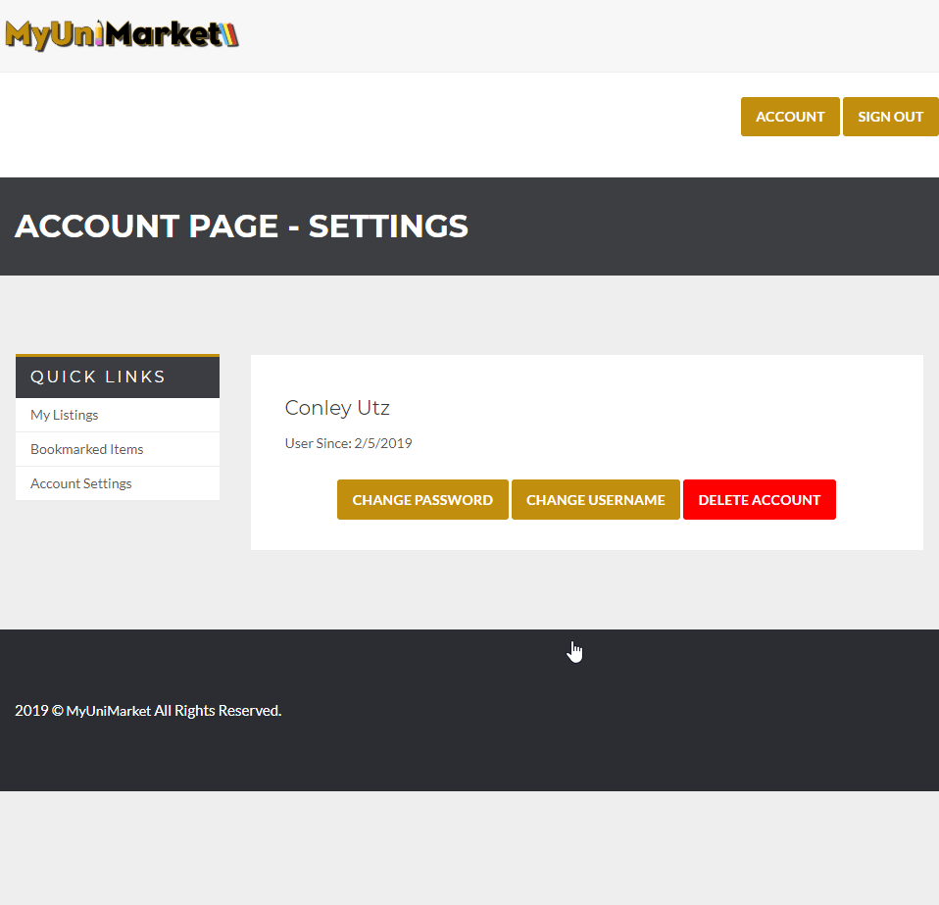
5. The hash of the password changes in the database. 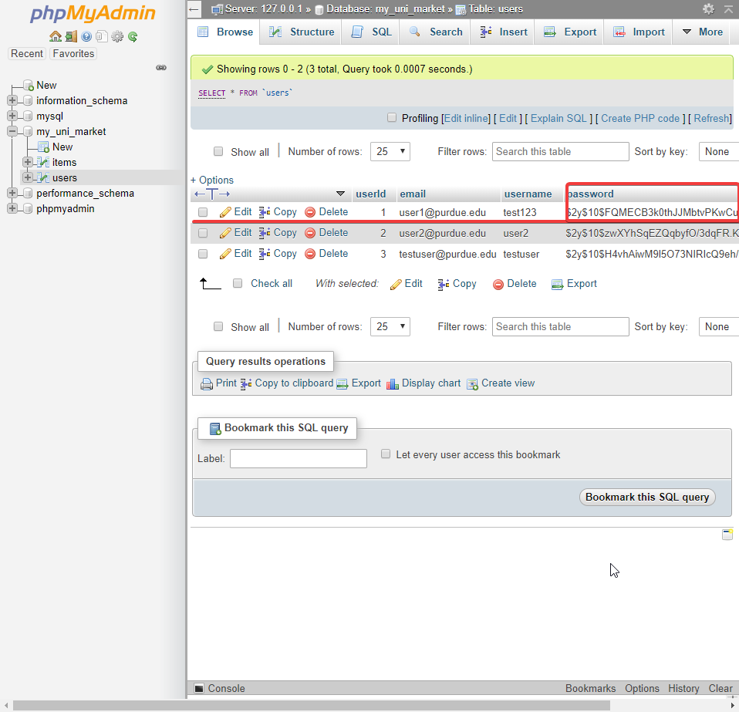

Expected Result: The password of the current user should change in the database.

Test Result: **PASSED**

**Test 3: Given that the user is logged in and has navigated to the account settings page, entering no information or incorrect information in any of the fields will give an error and reset the page.**

Purpose: To meet the acceptance criteria the user should be notified when they have not completed a field or have completed it incorrectly.

Steps:

1. The user clicks “CHANGE PASSWORD” 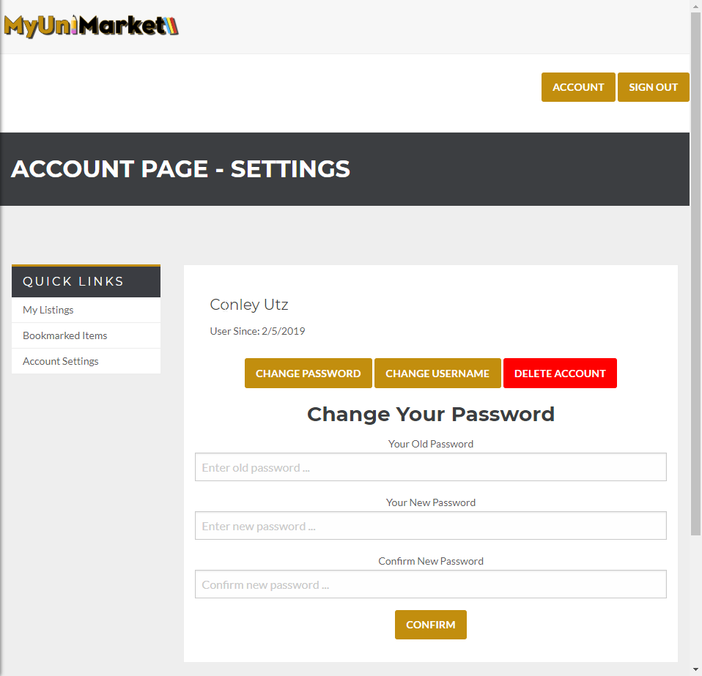
2. The user clicks confirm without entering any information 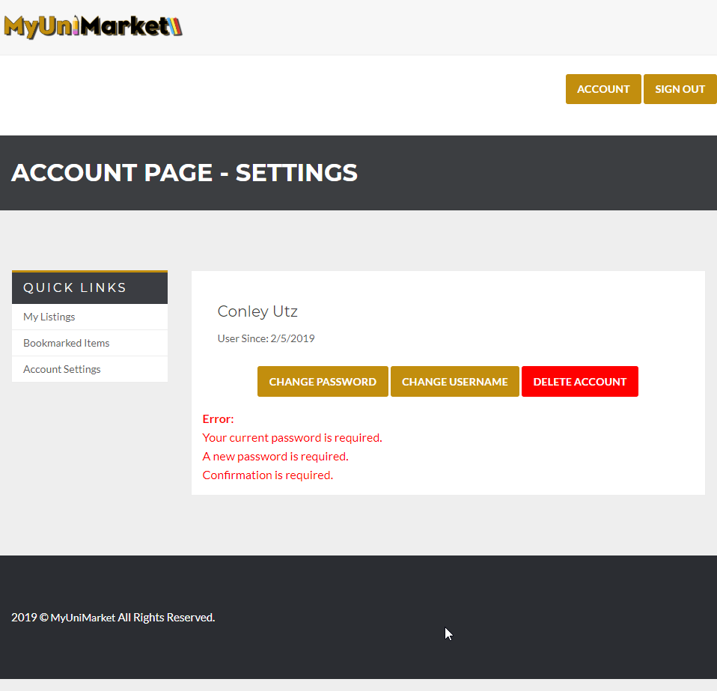
3. The user enters incorrect password and clicks confirm. 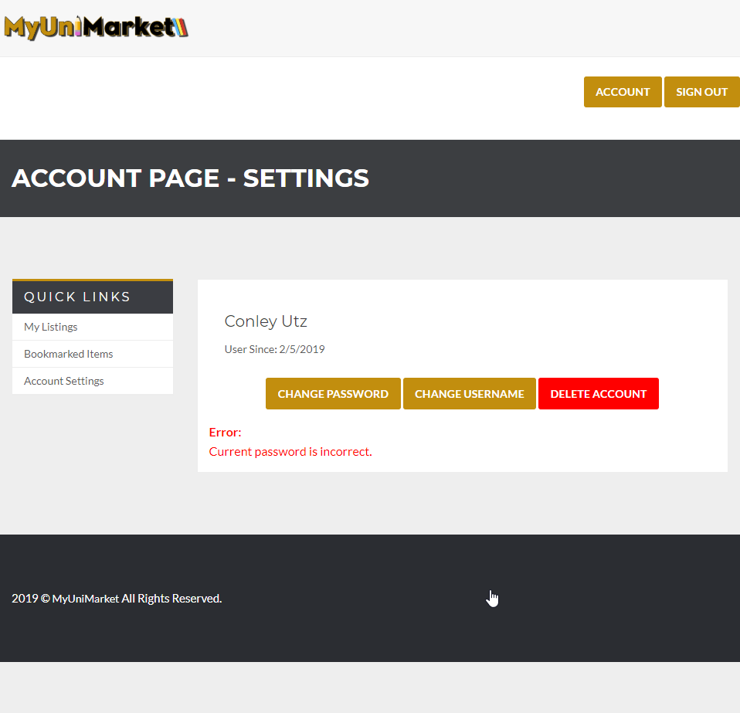
4. The user enters the current password correctly but enters the new password confirmation field wrong. 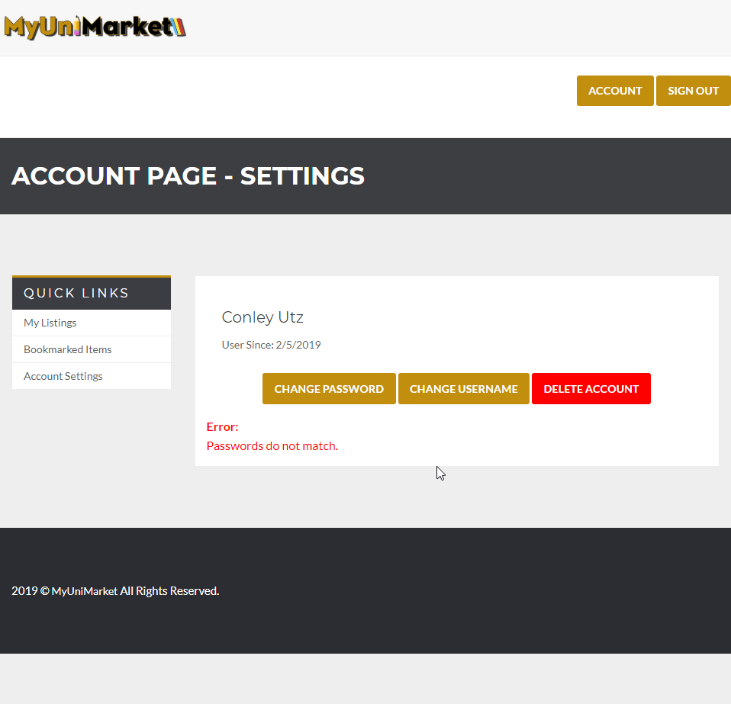
5. The user clicks “CHANGE USERNAME” 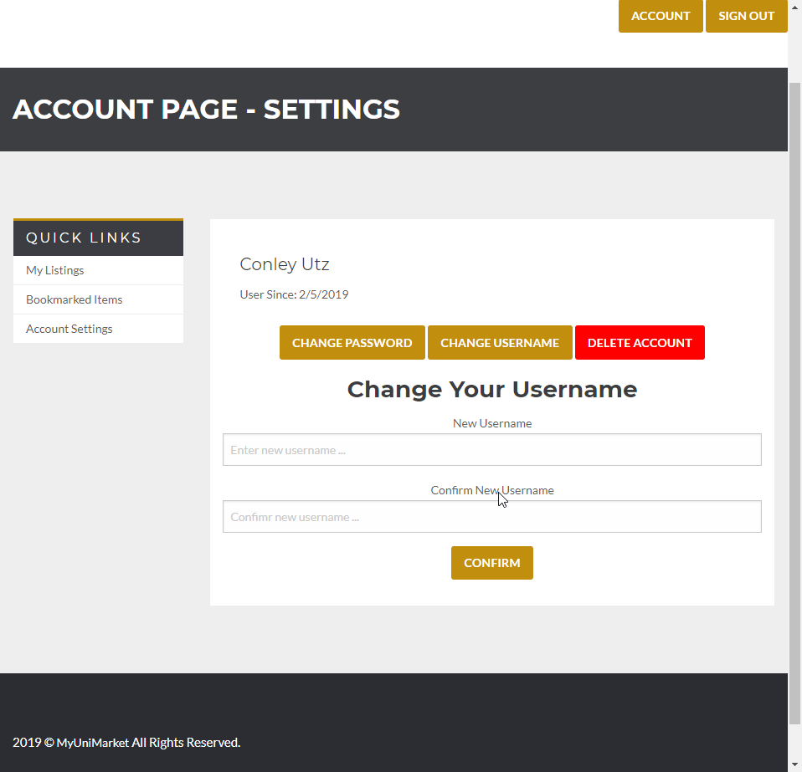
6. The user clicks confirm without entering any information 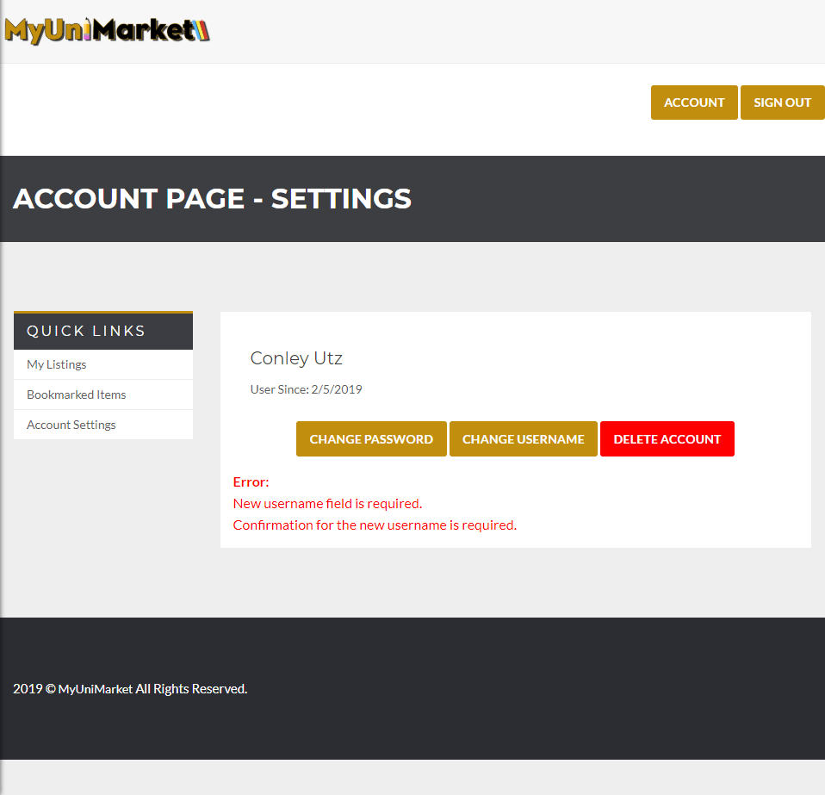
7. The user mistypes confirmation field 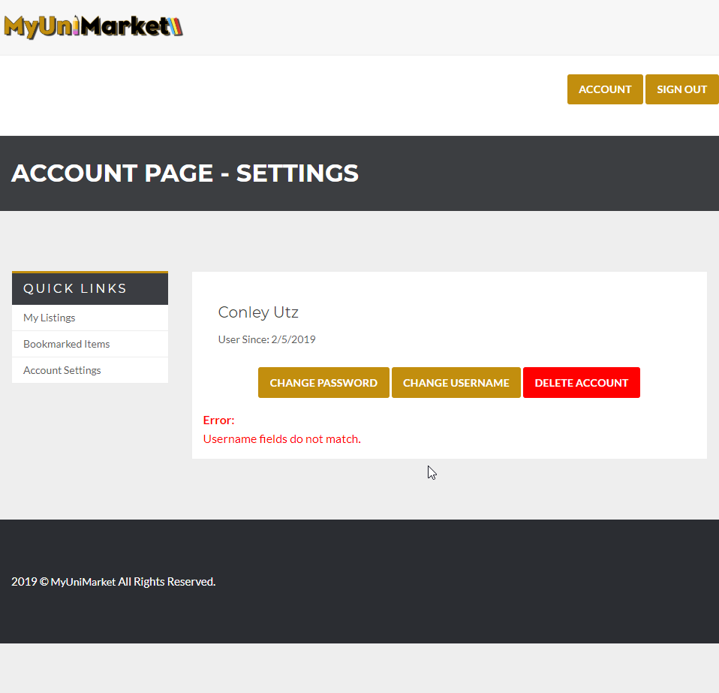

Expected Result: The website notifies the user when they have entered information incorrectly.

Test Result: **PASSED**